**ENHANCING SUSTAINABLE CONSUMPTION IN FASHION ACCESSORIES THROUGH AR-BASED VIRTUAL TRY-ON SYSTEMS IN VIETNAM**

Hoang Kim Nguyen1,2, Song Tin Ho1,2, Diem Thuy Nguyen Ngoc1,2, Hong Thi Bui Thi1,2, Bao Tran Giang1,2, Duy Thanh Tran1,2*  
1 Faculty of Information System, University of Economics and Law.

2Vietnam National University, Ho Chi Minh City, Vietnam  
*Corresponding Author Email: [thanhtd@uel.edu.vn](mailto:thanhtd@uel.edu.vn).

|  |
| --- |
| **A B S T R A C T** |
| In recent years, the growth of online shopping in Vietnam has made fashion items more accessible; however, it also presents issues in helping consumers assess whether a product truly matches their style or fits their body, especially for accessories where small design details matter. Without the ability to try items on, shoppers often rely on limited information and may purchase products that do not meet their expectations. This behavior contributes to unnecessary consumption, increasing environmental waste and raising concerns about sustainability.   |  |  | | --- | --- | | **Objective:**  This study proposes a mobile-based Virtual Try-On (VTO) system integrating Augmented Reality (AR) and Machine Learning (ML) to enhance the shopping experience and promote sustainable consumption. | | | **Research Design & Methods:**  Unlike platforms that rely on static images and generic suggestions, the system enables users to visualize accessories on their bodies in real time, using MediaPipe for landmark detection and Google Filament to render 3D models, without requiring specialized hardware. The prototype is optimized for smooth performance on most smartphones to ensure accessibility in the Vietnamese market. | | | **Findings:**  The proposed system is expected to enhance the shopping experience, minimize product waste, encourage more thoughtful decision-making, and promote sustainable consumption by supporting long-term environmental goals. | | | **Implications & Recommendations:**  This study provides a practical approach to encouraging thoughtful shopping habits and supporting sustainable purchase through accessible AR technologies. It enables Vietnamese fashion brands to apply AR and machine learning to better connect with customers, reduce waste, and deliver eco-friendly shopping experiences. | | | **Contribution & Value Added:**  This study contributes to the integration of augmented reality (AR) and sustainable consumption by introducing a lightweight, mobile-based Virtual Try-On (VTO) system tailored for the fashion accessories sector. The approach enhances the shopping experience, supports consumer decision-making, reduces unnecessary purchases, and contributes to waste reduction, ultimately promoting sustainable consumption. | | | **Article type:** | research article | | **Keywords:** | Augmented Reality, Virtual Try-On, Personalized Recommendation, Fashion Accessories, Mobile Application | | **JEL codes:** | L86 (1-3 JEL codes) | |

**1. INTRODUCTION**

The fashion industry, particularly the accessories sector, has experienced significant growth in recent years due to globalization and the rise of digital commerce. However, this expansion has also raised serious environmental concerns. According to Niinimäki et al. (2020), the fashion industry consumes approximately 79–93 billion cubic meters of water annually and is responsible for up to 10% of global carbon dioxide emissions, surpassing even international aviation and maritime shipping. Fast-changing trends, short product lifespans, and the frequent disposal of unsold or unused items have made fashion one of the most environmentally damaging industries. One of the key contributors to this unsustainable consumption is the inability of online shoppers to accurately visualize how products will look in real life, especially for small items such as rings, earrings, or bracelets. Without realistic previews, customers may make impulse purchases or order multiple options to choose from, leading to high excess waste.

Augmented Reality (AR), and more specifically Virtual Try-On (VTO) technology, offers a promising solution to this issue. VTO allows consumers to visualize how accessories would appear on their body before making a purchase, leading to more informed and sustainable shopping decisions. According to Zhou et al. (2023), AR significantly enhances consumer decision-making by reducing cognitive effort and increasing confidence during online shopping. In Vietnam, mobile e-commerce is expanding rapidly, particularly among Gen Z and Millennials. Nguyen et al. (2025) found that the perceived usefulness and enjoyment of AR-based VTO systems positively influence consumer purchase intentions. Previous studies have explored the use of AR in fashion and jewelry. For instance, Prajapat et al. (2022) and Egaji et al. (2019) developed AR-based systems for jewelry visualization but did not include shopping-related features such as booking, customer service, or account management. Ghosh et al. (2021) introduced personalized fashion recommendations using artificial intelligence, but did not involve AR for real-time product display. Miao et al. (2024) generated realistic jewelry try-on images with AI, though their system was limited to static visuals and lacked real-time interaction. In Vietnam, local study of Nguyễn Q.N. (2023) mainly focused on user attitudes and behaviors toward VTO, without building or testing a complete AR mobile application for ring try-on with full shopping features.

To address the limitations of prior research, this study proposes a comprehensive solution that not only enables real-time AR try-on for fashion accessories but also integrates essential shopping functionalities to support a complete and practical user experience. The primary objective is to design and implement a mobile shopping application that combines Augmented Reality (AR) and Machine Learning (ML) to allow users to preview accessories on their bodies in real time using a smartphone camera. By enhancing users' ability to assess product fit and appearance before purchase, the system aims to reduce product waste, encourage more thoughtful decision-making, and promote sustainable consumption by minimizing unnecessary purchases and supporting long-term environmental goals. The app includes supporting features such as account login, product browsing and purchasing, appointment booking, account management, and customer support. The system is built for Android smartphones and utilizes MediaPipe for hand landmark detection, ARCore for AR integration, and Google Filament for realistic 3D rendering. The main questions this project aims to address are: Can landmark detection ensure accurate and stable try-on of accessories using mobile devices? Can an AR interface help users better visualize products and feel more confident in their decisions? Can Machine Learning improve the user experience and support more responsible shopping behavior?

The following sections of the paper include a review of related research and theoretical foundations, a detailed description of the proposed system design, implementation results with screenshots and interface details, a discussion of system performance and limitations, and finally, a conclusion with suggestions for future development.

**2. THEORETICAL BACKGROUND AND RELATED WORK**

**2.1. Related Research**

The integration of Augmented Reality (AR) into fashion and jewelry retail has been widely studied by researchers aiming to improve user engagement, enhance product visualization, and reduce uncertainty in online shopping experiences. This research commonly focuses on the development of Virtual Try-On (VTO) technologies that allow consumers to preview accessories in real-time and within context.

Prajapat et al. (2022) introduced a jewelry try-on system utilizing AR and MediaPipe to enable users to visualize hand jewelry through mobile interfaces. Their study highlighted the limitations of conventional 2D imagery in capturing intricate design details, and demonstrated that AR simulations contribute to a clearer representation of products, ultimately increasing consumer confidence.

Further technical advancements were presented by Preeti et al. (2022), who proposed a system combining Unity 3D and Python-based image processing to enable real-time object detection and overlay on mobile devices. Their use of lightweight frameworks such as MediaPipe showcased the feasibility of deploying efficient AR solutions in commercial settings. Xiong et al. (2022), focused on enhancing visual realism through 3D garment simulation and physically based rendering techniques. Their work emphasized the effectiveness of markerless AR and detailed lighting models in providing a highly immersive try-on experience.

Within the Vietnamese context, Le and Nguyen (2024) conducted an empirical study examining the influence of virtual try-on features on consumer attitudes and behavior. They found that perceived usefulness and enjoyment strongly shaped purchase intent and brand trust, particularly among younger demographics. Nguyen (2022) explored AR adoption among small and medium-sized enterprises in the fashion sector, identifying internal factors—such as organizational innovativeness and openness to new technologies—as primary drivers of adoption, while financial constraints were less significant than expected.

Tran and Phan (2023) employed a mixed-method approach to investigate the acceptance of mobile AR applications. Their findings indicated that perceived usefulness, ease of use, and enjoyment were key determinants of behavioral intention. Moreover, technological experience was found to moderate the relationship between user attitudes and purchase decisions, highlighting the importance of digital literacy in facilitating successful AR integration.

Collectively, these studies provide valuable insights into both the technical and behavioral dimensions of AR adoption in fashion retail. From improvements in rendering accuracy to the psychological factors influencing user engagement, this body of research offers a comprehensive foundation for the development of effective AR-based virtual try-on systems, such as the one proposed in this project.

## 2.2. Theoretical Background

**Augmented Reality (AR)**

Augmented Reality (AR) overlays digital elements onto the real world, enhancing user perception and interaction. According to Azuma (1997), AR is defined by three key features: the integration of virtual and real elements, real-time interactivity, and precise 3D alignment with the physical environment. Unlike Virtual Reality (VR), which creates fully immersive digital spaces, AR enhances real-world contexts using tools like head-mounted displays, mobile devices, or spatial projectors.

AR has become a valuable asset in digital marketing and e-commerce, offering immersive alternatives to traditional shopping. Features such as virtual previews have been shown to improve user engagement, brand recall, loyalty, and conversion rates (Orús et al., 2021). Research also links AR to greater brand advocacy and long-term consumer retention (Kim et al., 2023; Olson et al., 2020). A survey by Somlith (2024) found that 71% of users were more likely to purchase products when AR tools were available. Milgram and Kishino’s (1994) Reality-Virtuality Continuum further situates AR within a spectrum of mixed reality technologies, distinguishing its ability to blend digital and physical environments.

**Virtual Try-On (VTO)**

Augmented Reality (AR) is increasingly applied in the jewelry industry to enhance the shopping experience, especially for items like rings and bracelets (Kang et al., 2020). AR-based Virtual Try-On (VTO) systems allow users to visualize jewelry on their hands via smartphone cameras, improving convenience and reducing the need for physical trials (Kim & Forsythe, 2008). These applications offer real-time interaction with virtual products, boosting engagement and trust while lowering e-commerce return rates (Hilken et al., 2017). Research shows that VTO features significantly enhance satisfaction and purchase intention, with 71% of users more likely to buy when such features are available (Kim et al., 2023; Orús et al., 2021; Somlith, 2024).

**Machine Learning**

Machine Learning (ML) is a core subfield of Artificial Intelligence (AI) that involves designing and developing algorithms capable of learning patterns from data and improving their performance on specific tasks over time, without being explicitly programmed. As defined by Mitchell (1997), “A computer program is said to learn from experience *E* with respect to some class of tasks *T* and performance measure *P*, if its performance at tasks in *T*, as measured by *P*, improves with experience *E*.” This formal definition underscores the three essential elements of ML systems: the data they learn from (experience), the problem they aim to solve (task), and how improvement is evaluated (performance measure).

In the context of Augmented Reality (AR), ML plays a crucial role in enabling intelligent, adaptive features that enhance user interaction. For example, ML algorithms are used to perform real-time facial recognition, pose estimation, gesture recognition, and object tracking—all of which are essential for creating responsive and immersive AR experiences. These capabilities allow virtual content to be dynamically aligned with the user's body movements or facial expressions, making AR interactions feel natural and intuitive.

To achieve this, ML models are trained on large datasets containing thousands (or even millions) of annotated images or sensor readings. These datasets help the models learn complex spatial relationships, detect subtle patterns, and generalize across varied lighting, angles, and user demographics. As a result, AR systems can identify and track features like eyes, hands, or facial landmarks with high accuracy, even in diverse real-world environments.

**MediaPipe Framework Architecture**

MediaPipe is an efficient real-time perception framework optimized for mobile and low-resource environments. It employs a two-stage pipeline—detect-then-track or detect-then-refine—to balance accuracy and computational cost. By alternating between full detection and lightweight tracking, MediaPipe reduces processing demands while maintaining performance (Lugaresi et al., 2019; Bazarevsky et al., 2020; Zhang et al., 2020).

The Face Mesh module predicts 468 or 478 3D landmarks from a single RGB image using BlazeFace for initial detection and a MobileNetV2-based regressor for landmark estimation (Bazarevsky et al., 2020; Howard et al., 2019). The advanced Attention Mesh model further enhances accuracy in detailed regions like the eyes and lips, though with increased latency (Google, 2023b). Outputs include 3D coordinates, 52 blendshape parameters, and a 4×4 pose matrix.

MediaPipe Hands detects 21 2D/3D keypoints per hand using palm detection followed by keypoint regression. Trained on a large dataset of real and synthetic images, it enables efficient tracking by referencing previous frames and re-detecting only when needed (Zhang et al., 2020). It also classifies handedness for contextual accuracy.

Together, these modules provide robust and scalable solutions for real-time AR experiences, supporting highly interactive applications with smooth visual alignment and reliable motion tracking across varied conditions.

**Google Filament**

Google Filament is a real-time, physically based rendering engine optimized for mobile and cross-platform performance. It uses physical units (e.g., lumens, Kelvin) and provides a minimal, developer-friendly API in C++ and Java/JNI (Google, 2019). Built on top of graphics APIs like OpenGL, Vulkan, and MoltenVK, Filament avoids runtime shader compilation by using *matc*, which pre-compiles materials into optimized binaries.

Filament ensures realistic reflections through a physically based model that respects energy conservation and roughness-driven light scattering. Its standard lit material model uses intuitive parameters such as *roughness*, *metallic*, and *baseColor*, with the *metallic* parameter determining whether the base color represents diffuse reflection (for dielectrics) or specular reflection (for metals), thereby enforcing physically plausible results and consistent behavior under dynamic lighting (Google, 2023).

**3. PROPOSED MODEL AND SOLUTIONS**

**3.1. Proposed Model**

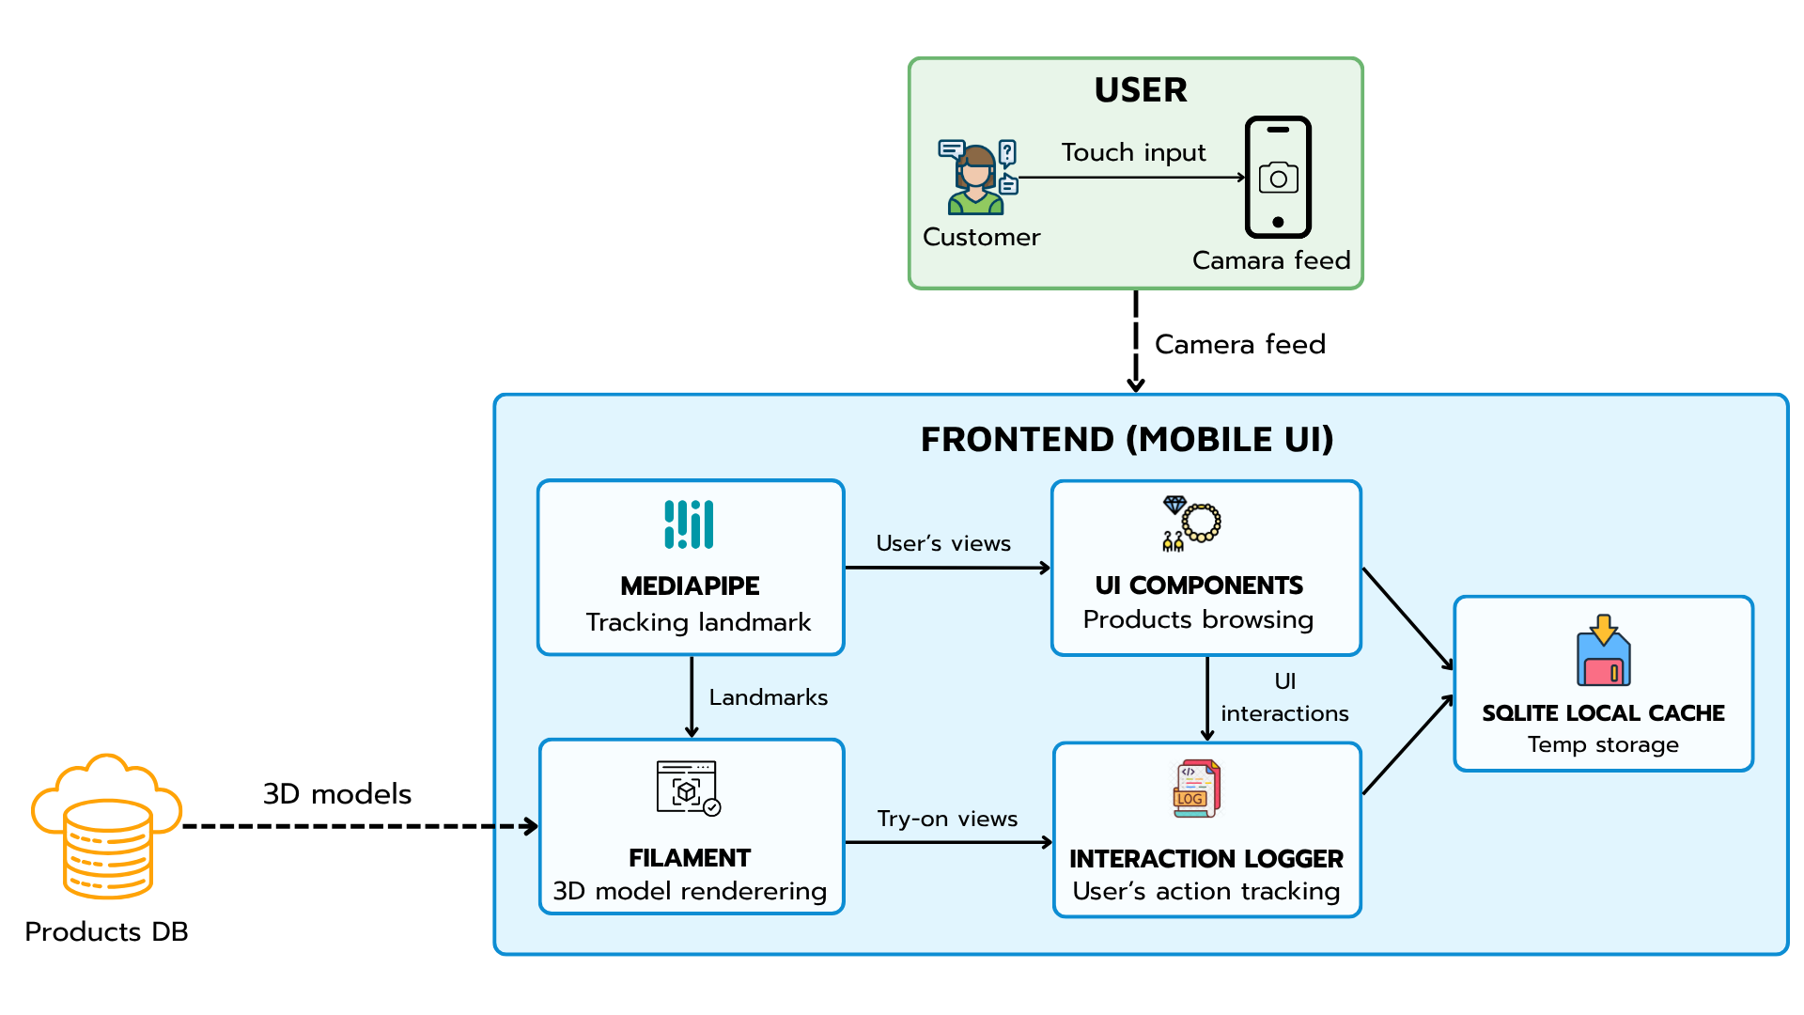

##### **Figure 1.** Proposed Model (Source: Authors)

The interaction process begins when users engage with the mobile application via touch input, triggering the device’s camera. The live feed is processed in real time using MediaPipe, which detects and tracks hand landmarks essential for accurate positioning of virtual jewelry. These landmarks are then used by Filament, a real-time rendering engine, to overlay photorealistic 3D models onto the user's hand, enabling an immersive try-on experience.Concurrently, UI Components facilitate product browsing, selection, and in-app navigation, allowing users to interact seamlessly with the system. As users explore and try on accessories, their actions are captured by the Interaction Logger, which records behavioral data and temporarily stores it in the SQLite Local Cache to support offline access and ensure smooth performance.Throughout this process, 3D models are dynamically retrieved from the Products Database and rendered in alignment with the user’s movements. This modular frontend architecture enables precise AR rendering, efficient data handling, and a user-centered experience optimized for mobile platforms.

**3.2. Data and Process Modeling**

**Context Diagram Data Flow Diagram**

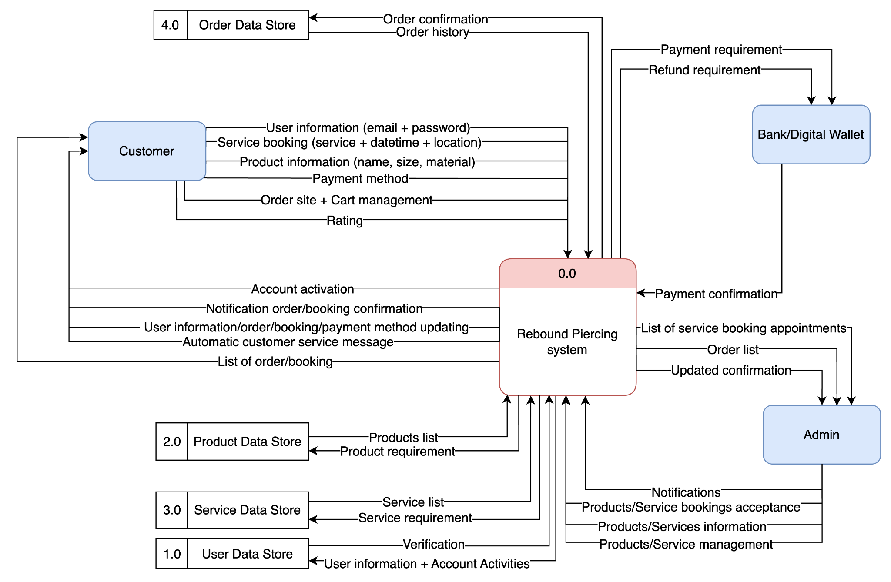

##### **Figure 2.** Context Diagram Data Flow Diagram (Source: Authors)

### **Customer Mobile Application Business Process Model and Notation Diagram**

[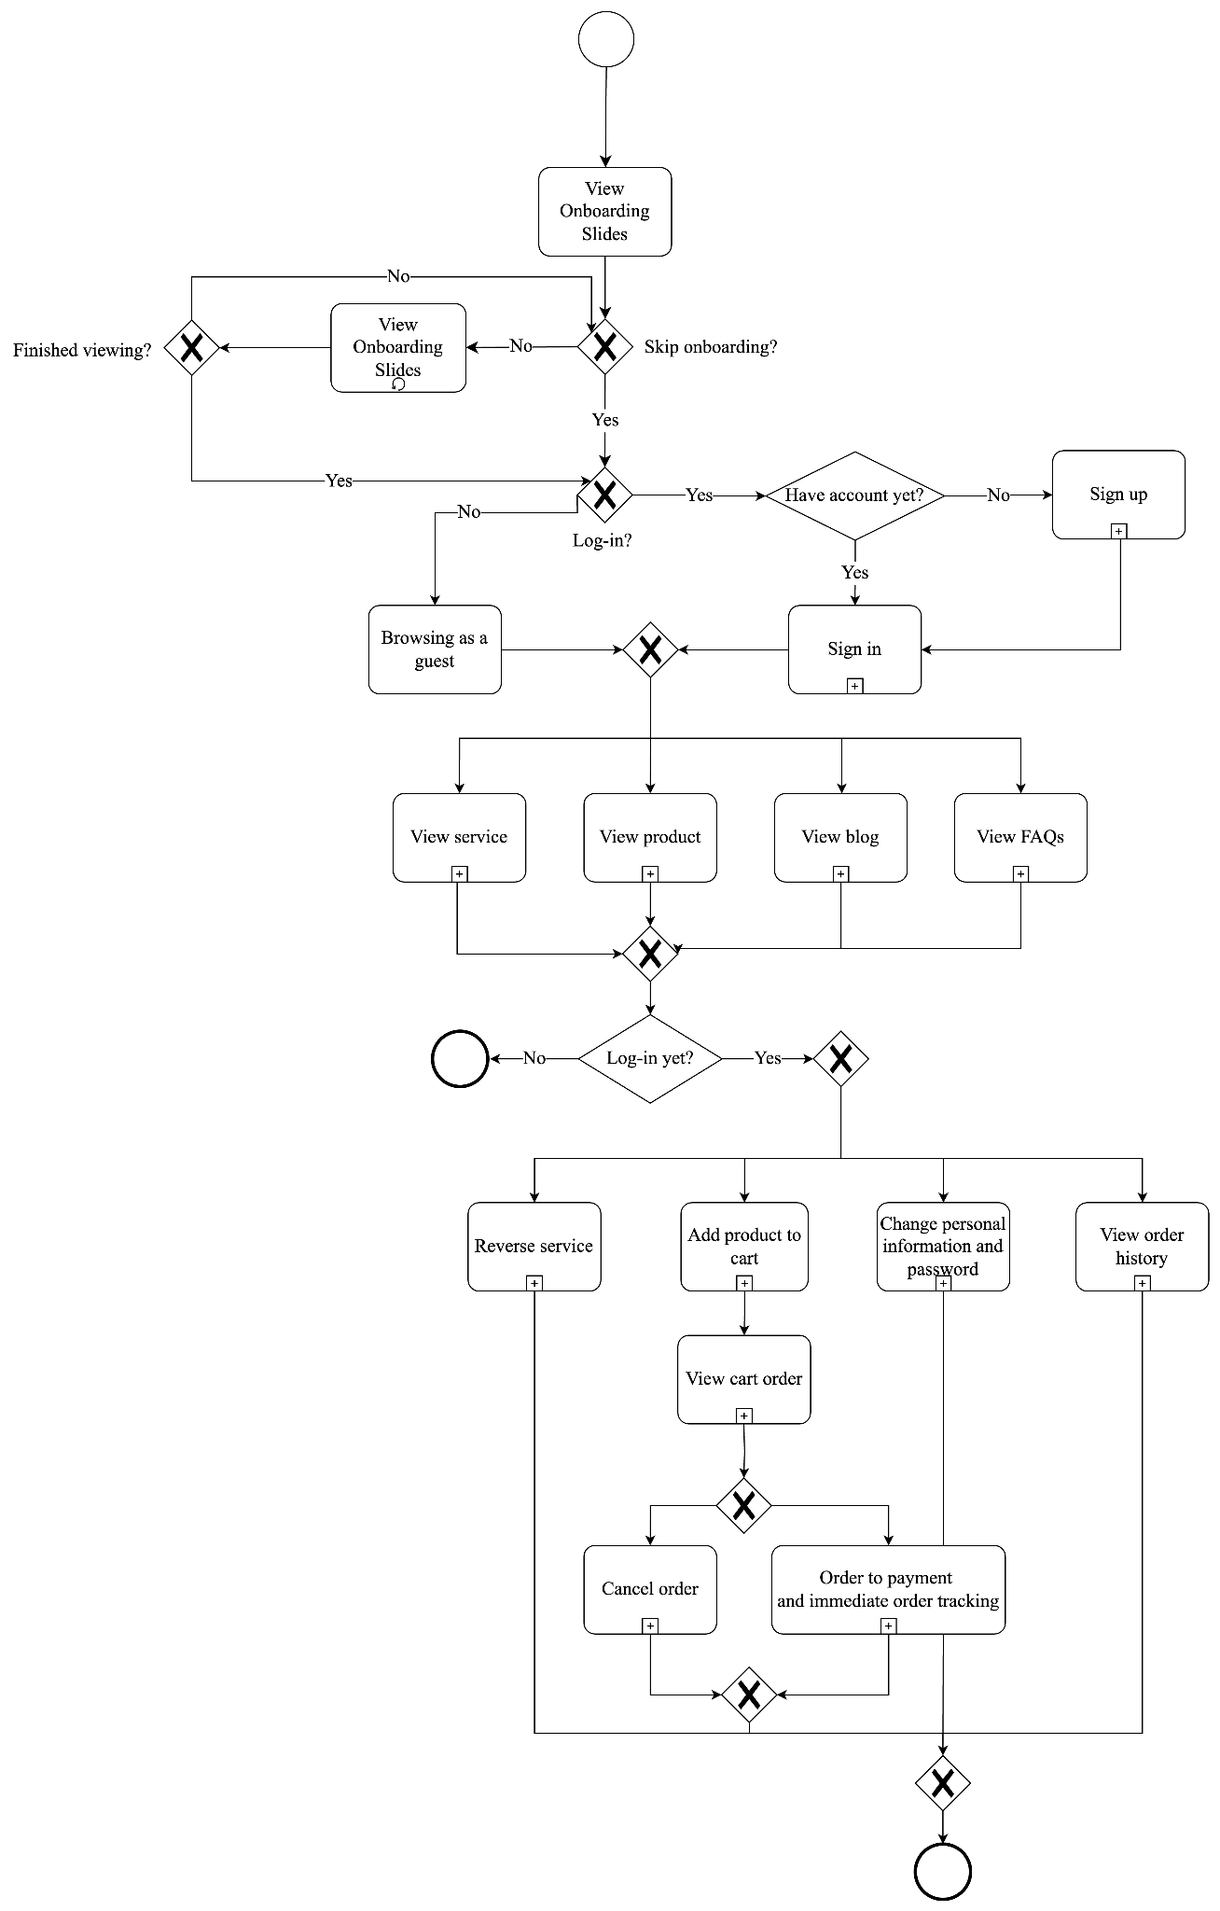](https://app.diagrams.net/?splash=0#%7B%22pageId%22%3A%22RM9aCieiRxkna2eNcdIy%22%7D)

##### **Figure 3.** The General BPMN Diagram of The Customer Mobile Application (Source: Authors)

This BPMN diagram illustrates the end-to-end flow for a typical customer using the luxury e-commerce app. It begins with app launch and proceeds through onboarding (if new), user authentication (login/sign-up/guest), browsing services, viewing products, reading blogs, or accessing support content. For advanced features like cart and booking, the system checks user authentication. Logged-in users can manage profiles, book services, and make purchases. The process concludes with order placement and tracking.

## 3.3. Authentication

### **Business Process Model and Notation Diagram**

[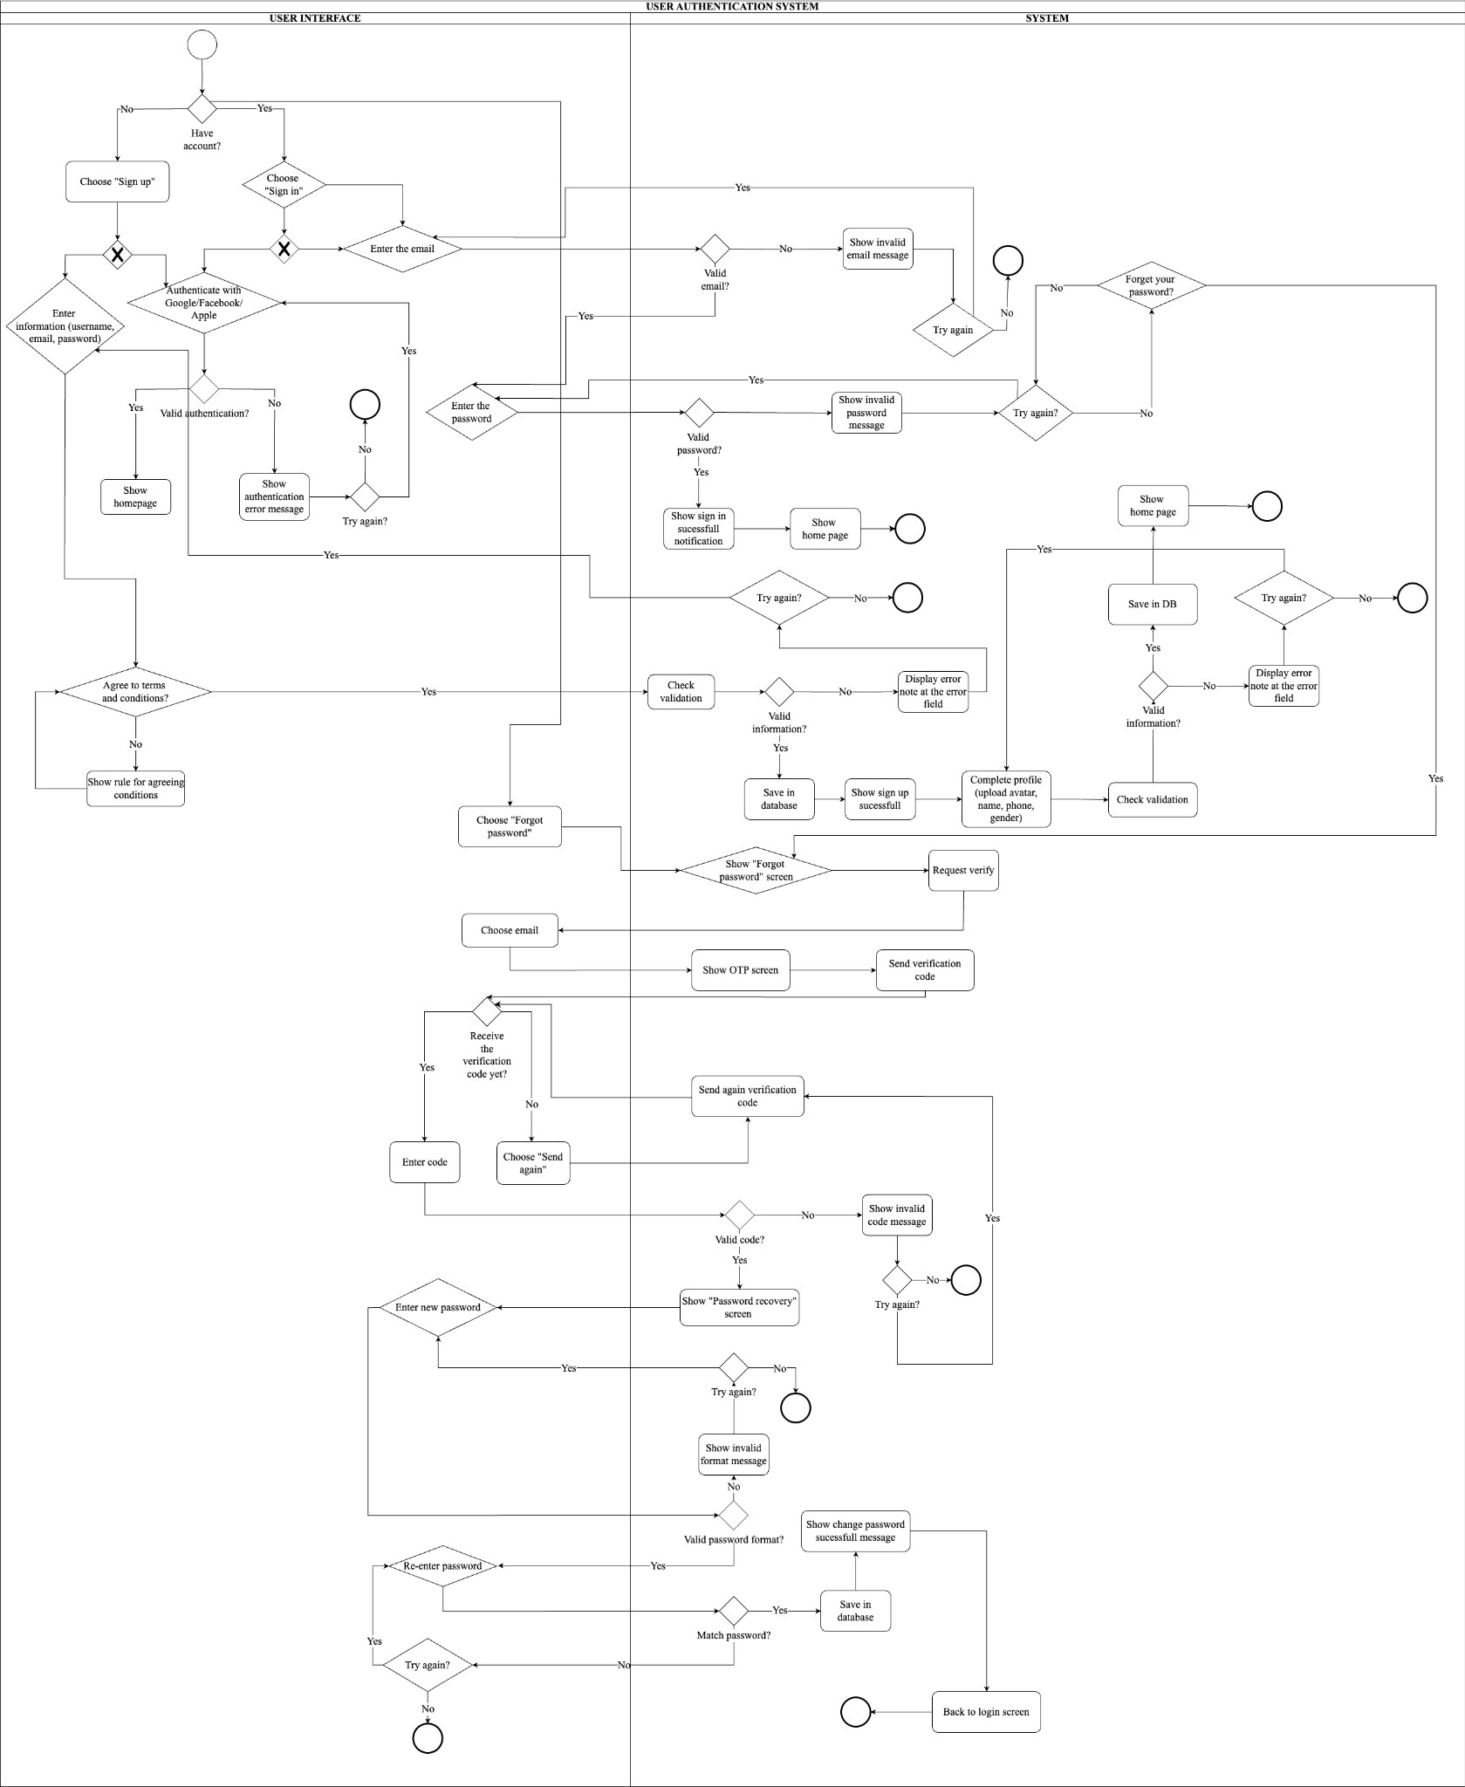](https://app.diagrams.net/?splash=0#%7B%22pageId%22%3A%22iQZaYYilHzHohgkhlVtu%22%7D)

### **Figure 4.** The BPMN Diagram of Authentication Function (Source: Authors)

### The authentication BPMN diagram outlines user interaction across three swimlanes: User Interface, System, and Authentication Logic. Users can sign up, log in, or recover passwords. The system validates credentials and manages account creation, login access, or password reset using OTPs. Each flow includes exception handling (e.g., wrong password, invalid OTP) and user feedback, ensuring secure access control.

**Use Case Diagram**

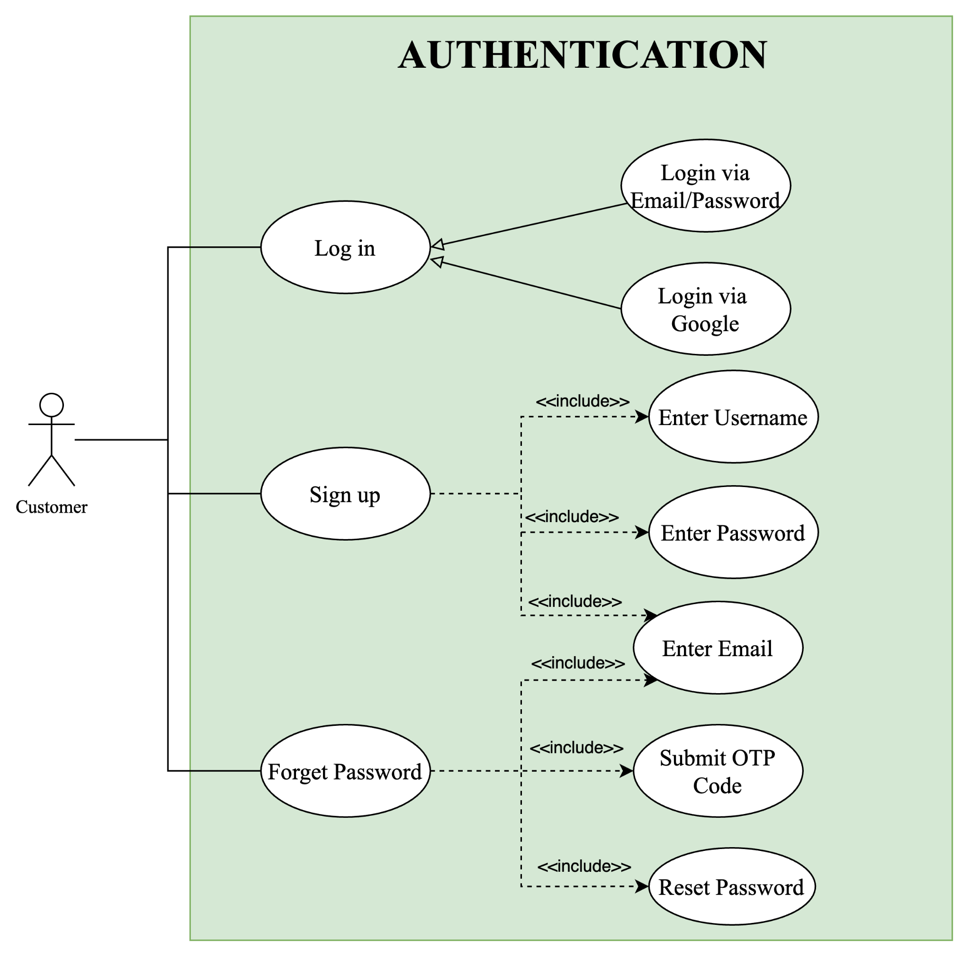

**Figure 5.** Authentication Use Case Diagram (Source: Authors)

Authentication includes three key use cases: Log In, Sign Up, and Forget Password. In the Log In flow, users enter credentials or use Google OAuth; valid attempts are redirected to the dashboard, while invalid ones trigger appropriate messages. For Sign Up, new users provide personal data which is validated—such as checking for unique emails or strong passwords—before being registered and logged in automatically. The Forget Password flow lets users reset credentials through email-based OTP verification, with checks for correctness and security. These use cases balance user convenience with system security, offering a streamlined access experience.

## 3.4. Product Browsing & Purchase

**Product Interaction Business Process Model and Notation Diagram**

[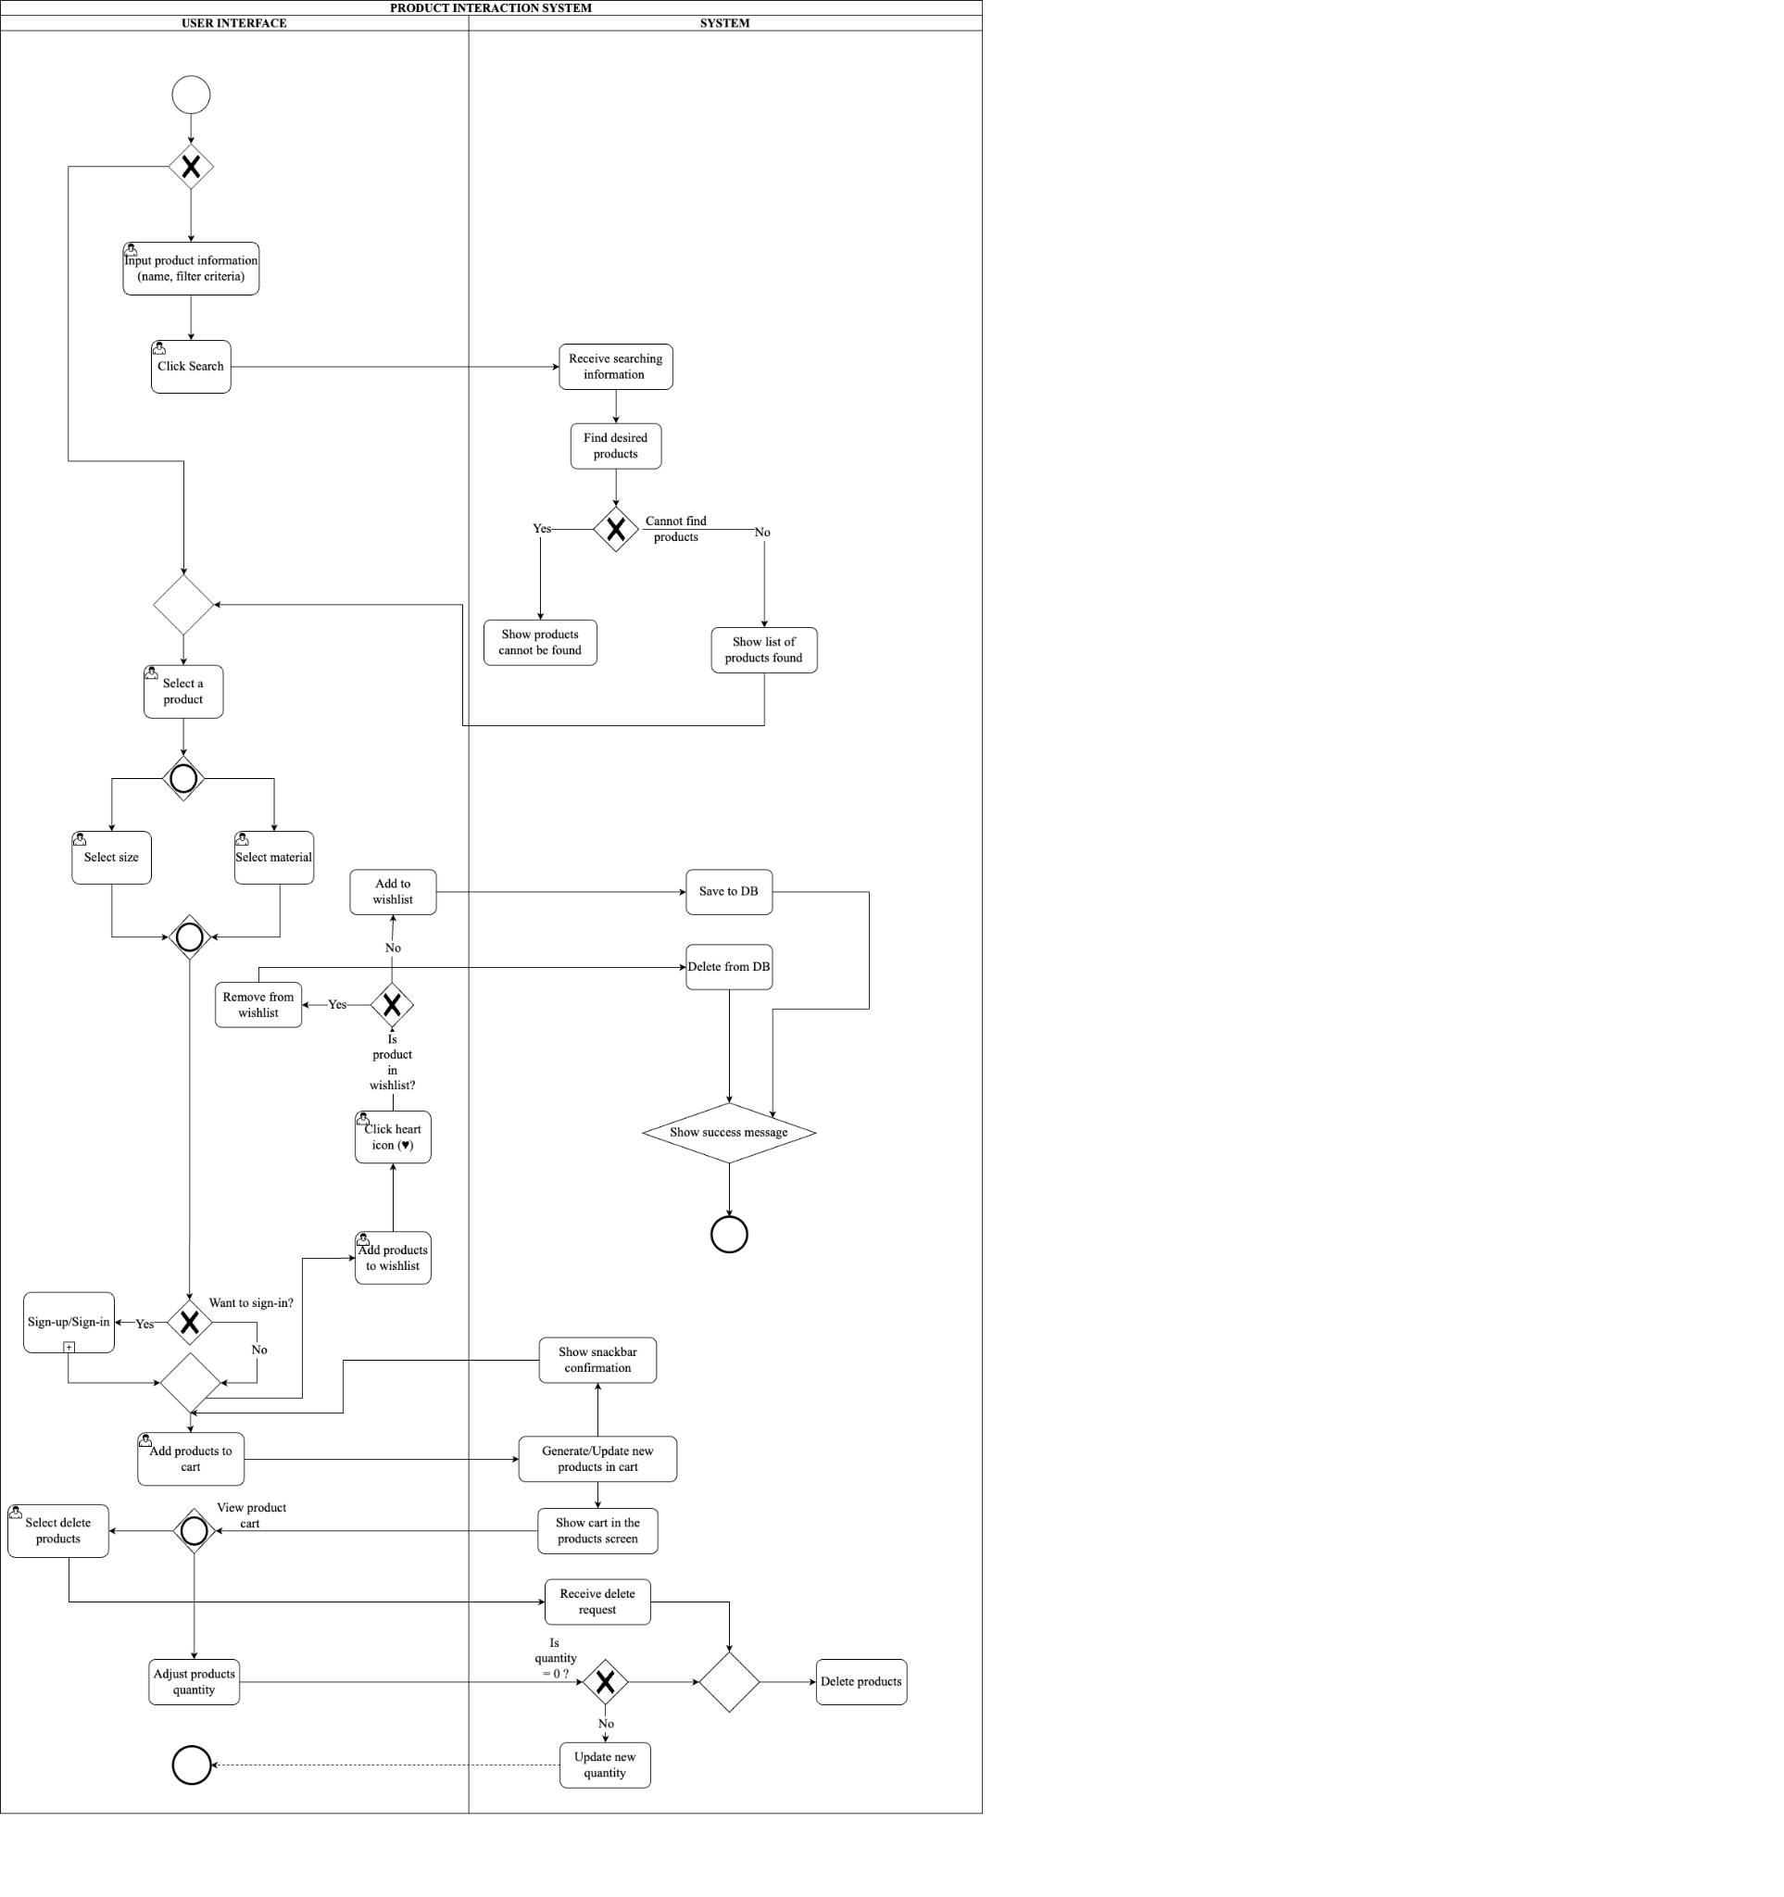](https://app.diagrams.net/?splash=0#%7B%22pageId%22%3A%22B46H7bgj8S_LPccnehya%22%7D)

##### **Figure 6.** The BPMN Diagram of Product Interaction Function (Source: Authors)

This feature is represented through two diagrams: Product Interaction and Payment Flow. The Product Interaction diagram shows how users search, view, and manage products—interacting with lists, detail pages, wishlists, and carts. The system handles login prompts, stock checks, and confirmation messages. The Payment Flow diagram begins with cart review, shipping confirmation, and voucher application, followed by payment via COD, Card, or QR code. The system validates each option and activates order tracking through APIs. Errors such as payment failures are handled gracefully.

**Payment Flow Business Process Model and Notation Diagram**

[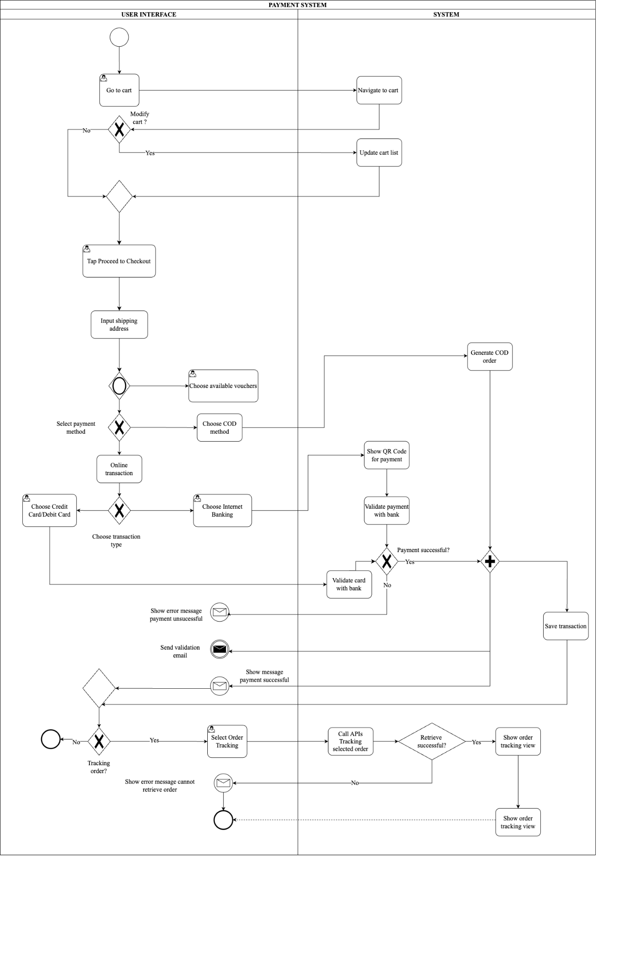](https://app.diagrams.net/?splash=0#%7B%22pageId%22%3A%22RJZyb9Jr-5fXpzKlQfTv%22%7D)

##### **Figure 7.** The BPMN Diagram of Payment Function (Source: Authors)

This diagram shows how users complete payments and track orders in the app, from reviewing the cart and choosing a payment method (COD, card, or internet banking) to order confirmation. The system processes each method accordingly and enables order tracking via API, with full or partial delivery updates shown based on data availability.

### **Use Case Diagram**

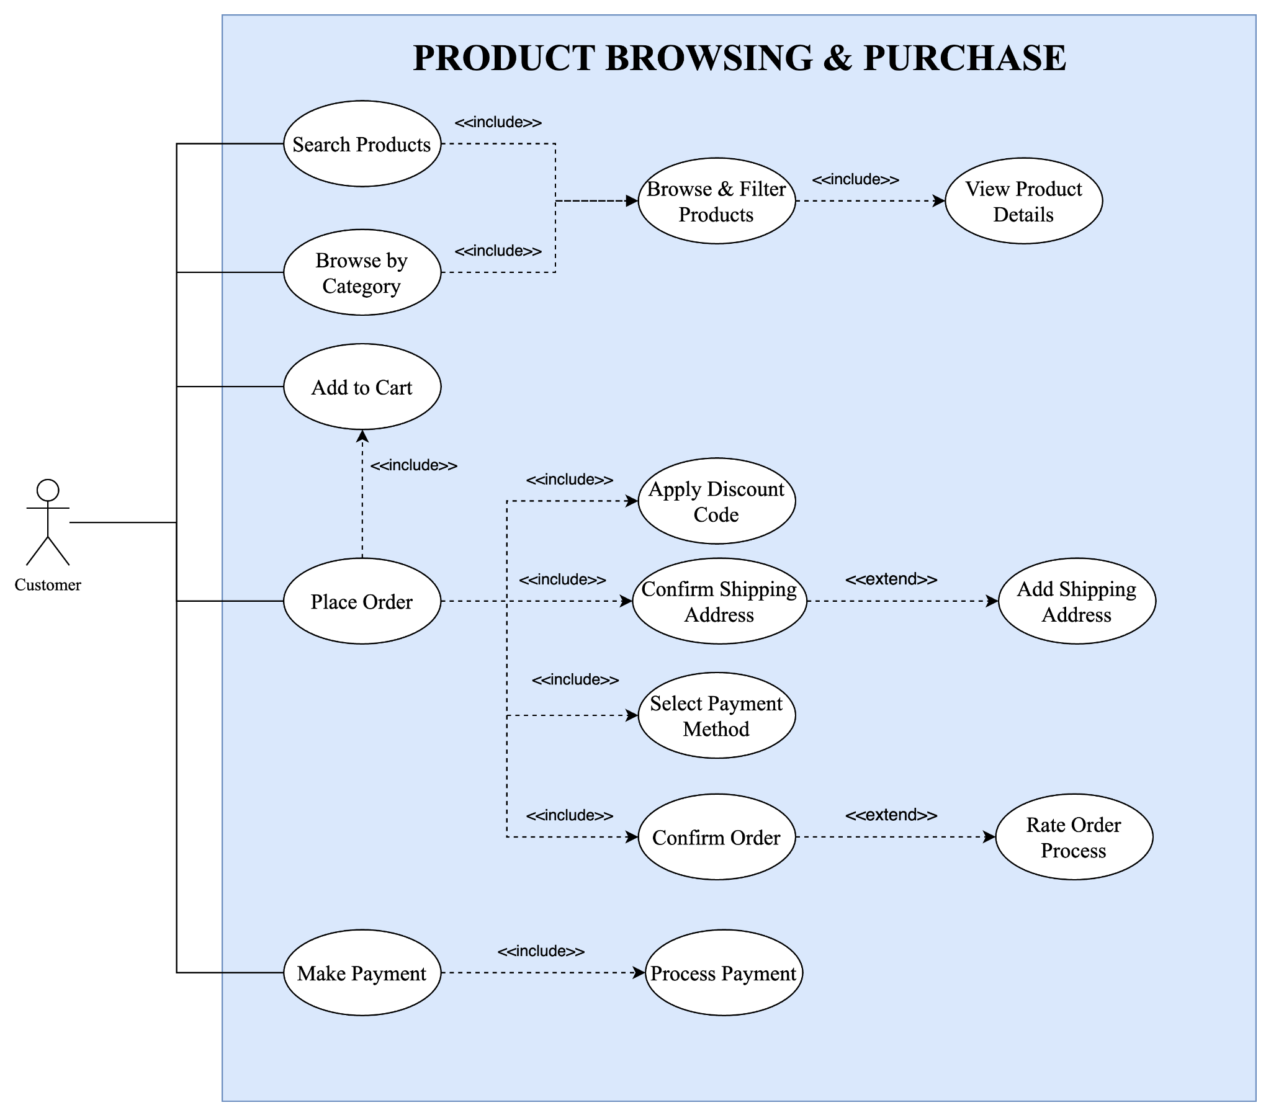

**Figure 8.** Product Browsing & Purchase Use Case Diagram (Source: Authors)

### The shopping journey includes five main use cases: Search Products, Add to Cart, Place Order, Make Payment, and Rate Order. Users search by keywords, and the system returns matching products or suggestions if none are found. When adding items to cart, the system checks login status and stock availability. During checkout, users confirm items, apply vouchers, and select delivery details. Payment is processed securely through the chosen method, with errors managed and successful transactions confirmed. After receiving products, users can rate the order, and the system stores this feedback to improve future experiences. These use cases together support a seamless and interactive shopping flow.

**3.5. Booking Service System**

**Business Process Model and Notation Diagram**

[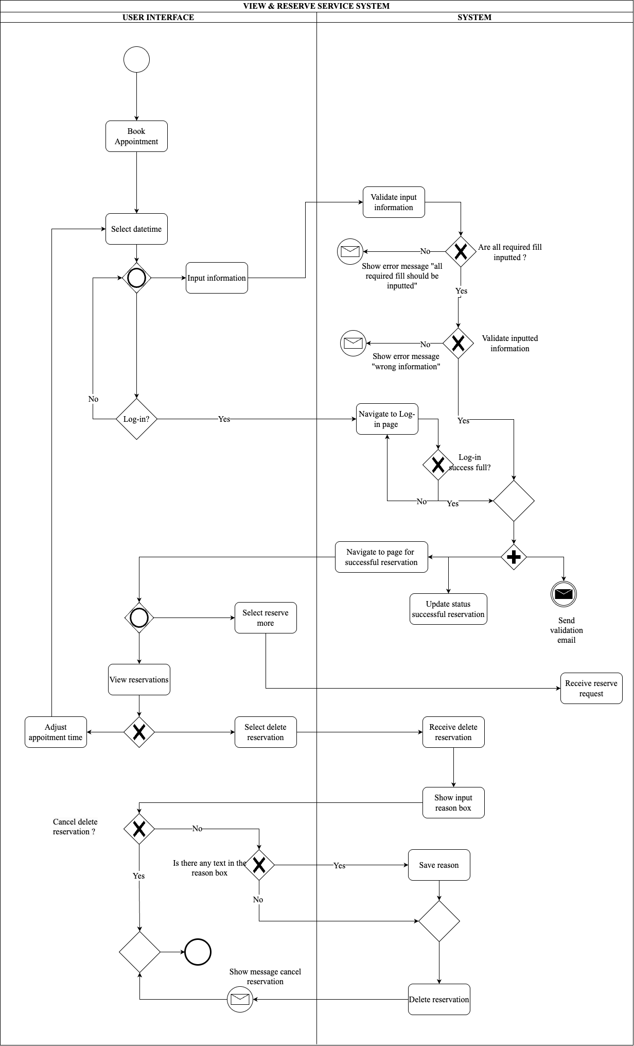](https://app.diagrams.net/?splash=0#%7B%22pageId%22%3A%2297HKh3Ap_9komxGaLfqd%22%7D)

##### **Figure 9.** The BPMN Diagram of Booking Service Function (Source: Authors)

This BPMN illustrates how users book and manage appointments. Users select the service, date, and time, while the system verifies login status and availability. Once confirmed, users can view, modify, or cancel their bookings. For cancellations, a reason is required. The process includes exception handling for invalid inputs or booking conflicts to ensure smooth operation.

**Use Case Diagram**

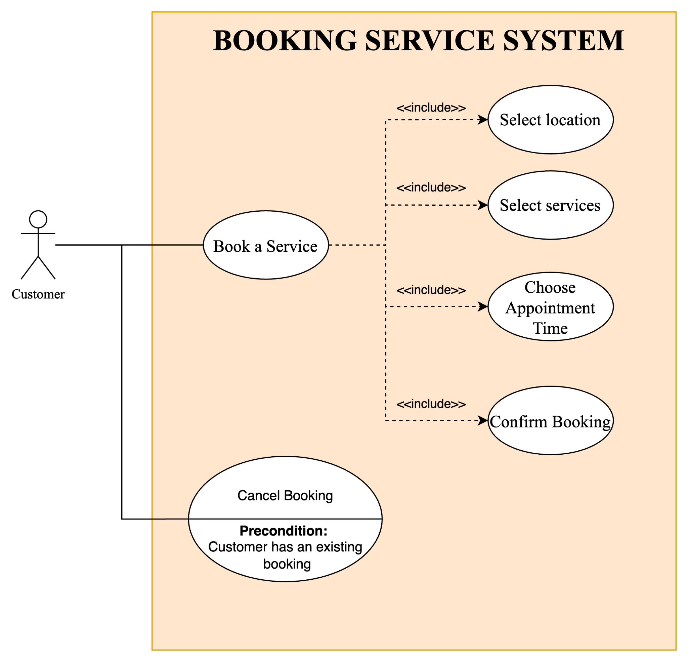

**Figure 10.** Booking Service System Use Case Diagram (Source: Authors)

### This module includes two main use cases: Book a Service and Cancel Booking. In the booking flow, users select the desired service, location, and time slot. The system checks availability and confirms the booking, suggesting alternatives if unavailable. If errors occur, prompts are shown for correction. For cancellations, users access their booking history, choose a reservation, and confirm cancellation along with a reason. The system records the action and updates the status. These use cases provide a flexible, user-friendly system for managing service appointments.

**3.6. AR Camera System**

**Business Process Model and Notation Diagram**

### This BPMN illustrates the AR try-on flow for jewelry. Users select a jewelry type, and the system checks input validity before activating the AR camera. If permission is denied, the process ends with a warning. If granted, users can try on items, switch views, or take snapshots. The session ends when the user exits the AR feature.

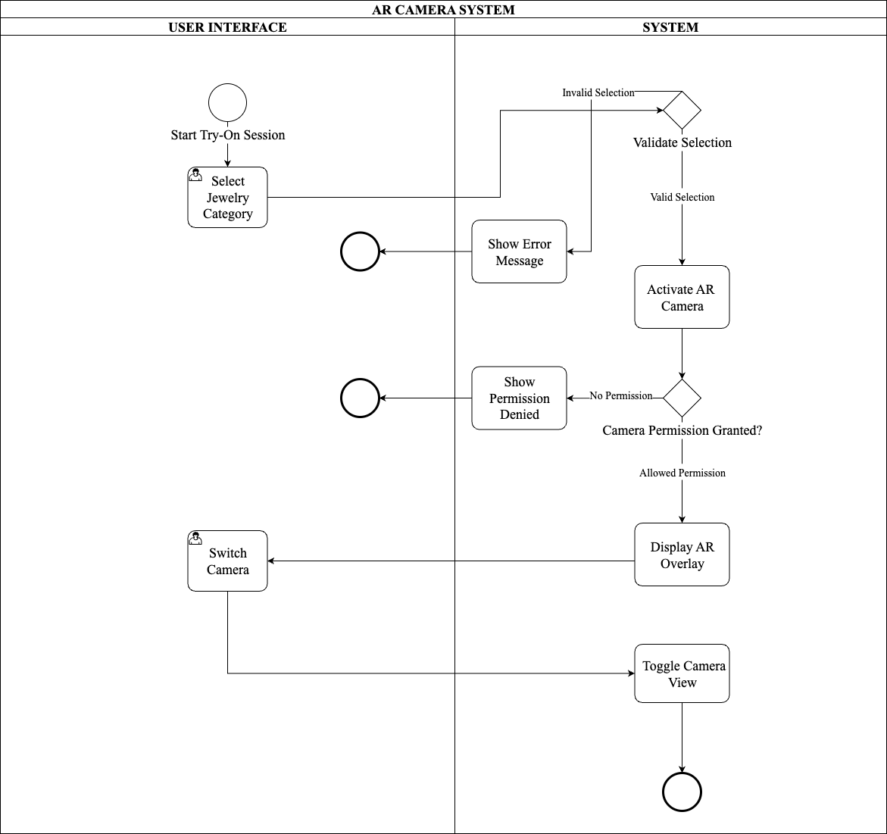

##### **Figure 11.** The BPMN Diagram of AR Camera System Function (Source: Authors)

### **Use Case Diagram**

### The AR module includes three use cases: Try on Jewelry, Capture AR Snapshot, and Switch Camera. In the try-on process, users activate AR, choose items, and view them in real-time via camera overlay. The system checks permissions and model compatibility, handling issues like access denial or misalignment. Users can also take snapshots during sessions, with the system saving or allowing sharing as needed. Switching between front and rear cameras is supported while maintaining AR accuracy. These features enhance the shopping experience through interactive visualization.

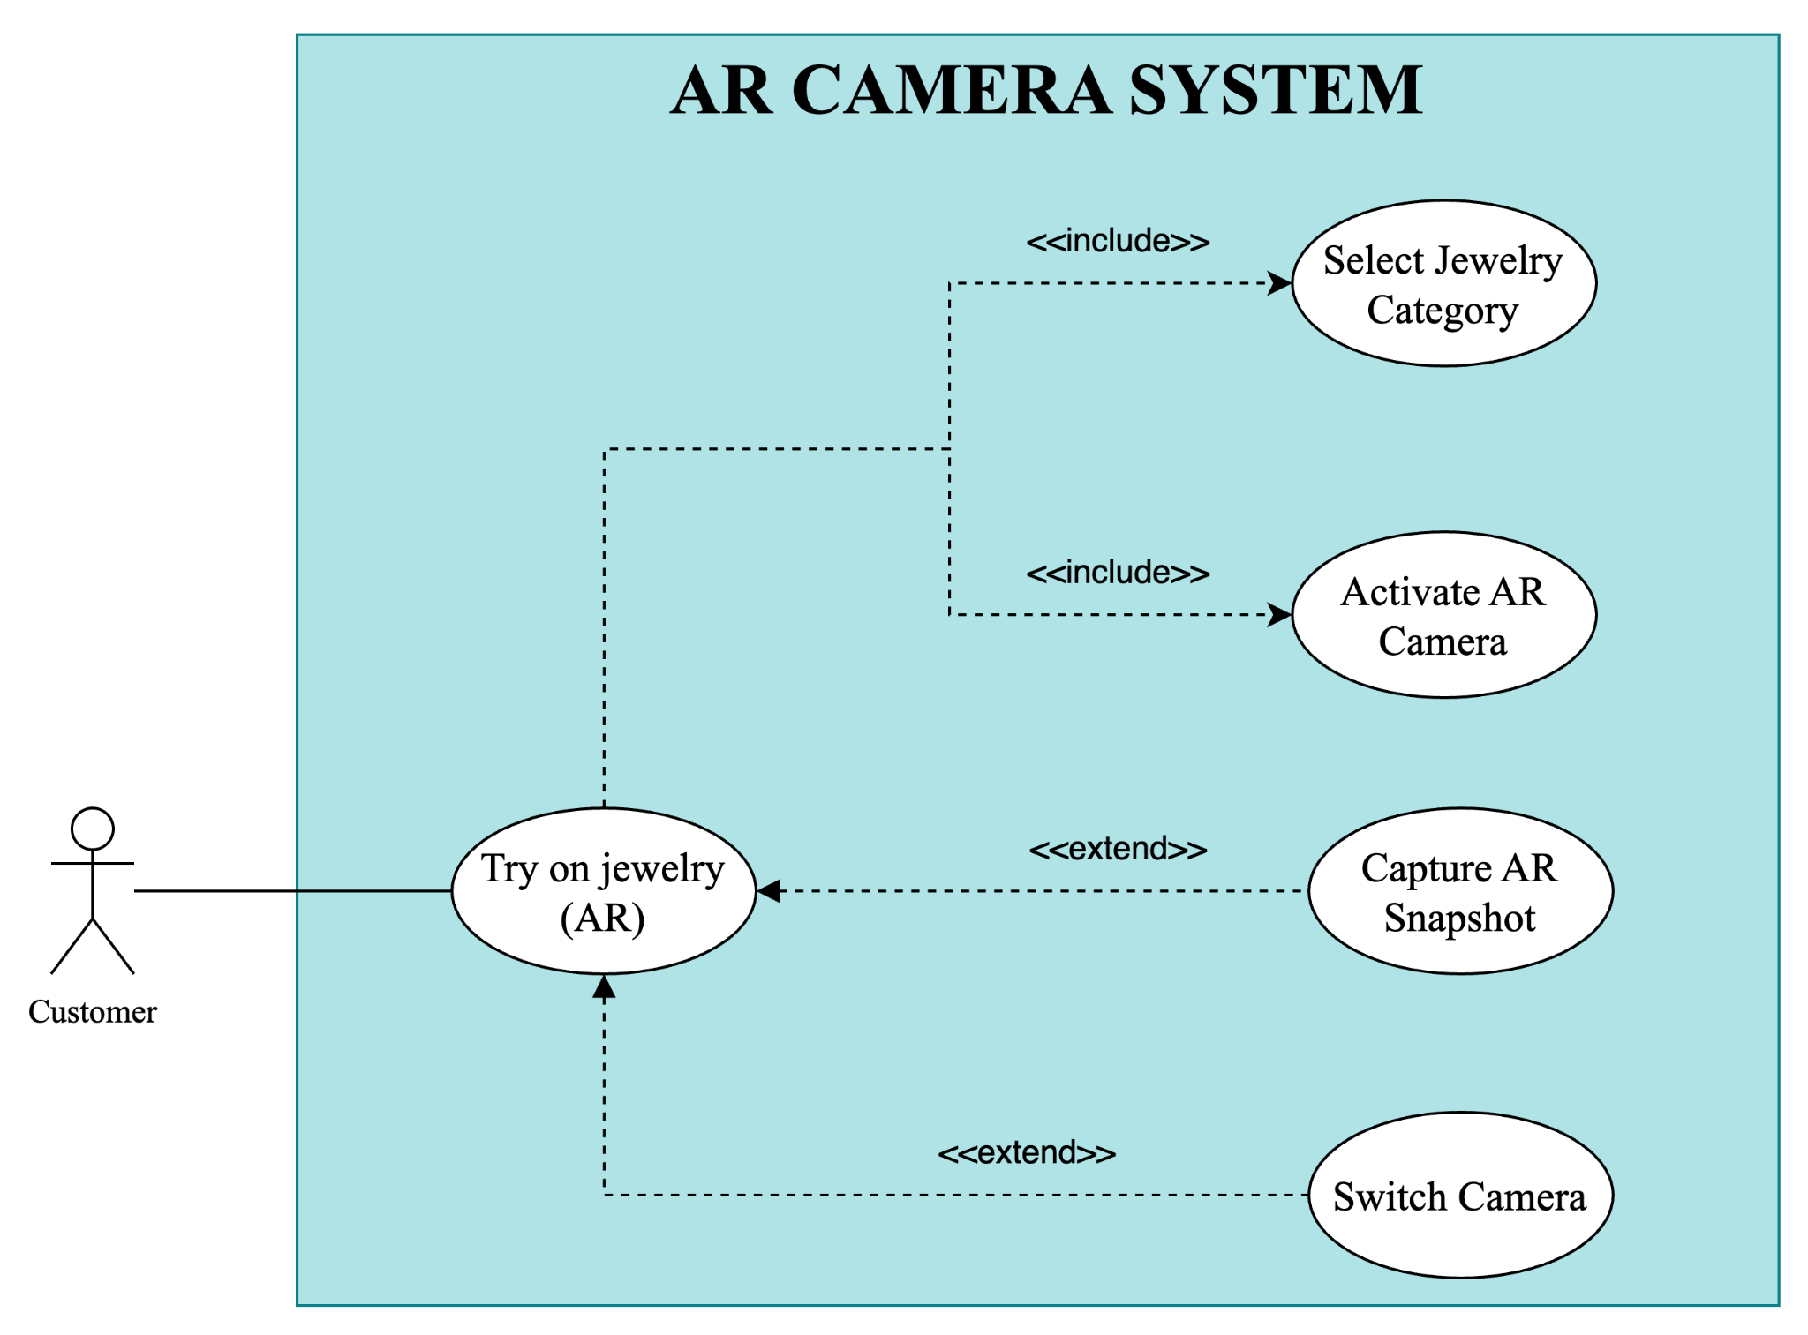

**Figure 12.** AR Camera System Use Case Diagram (Source: Authors)

# 4. IMPLEMENTATION RESULTS

## 4.1. Authentication Process to Homepage User Interface

## 

##### **Figure 13.** Introduction and Splash Screens User Interface (Source: Authors)

When first opening the app, users see the Welcome screen (screen 1). New users can tap “Register” to create an account. After successful registration, three splash screens (screens 2–4) introduce the app’s key features and usage.

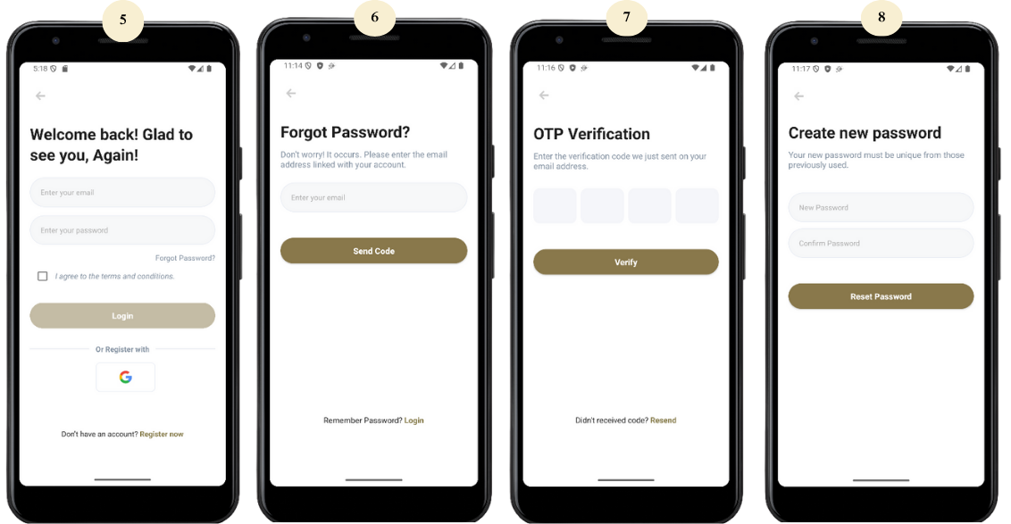

##### **Figure 14.** Login and Reset New Password Process User Interface (Source: Authors)

Users with an account can tap “Login” to access screen 5, then sign in via email/password or Google. If they forget their password, tapping “Forgot Password?” starts the recovery process. After email input (screen 6) and OTP verification (screen 7), they can set a new password on screen 8.

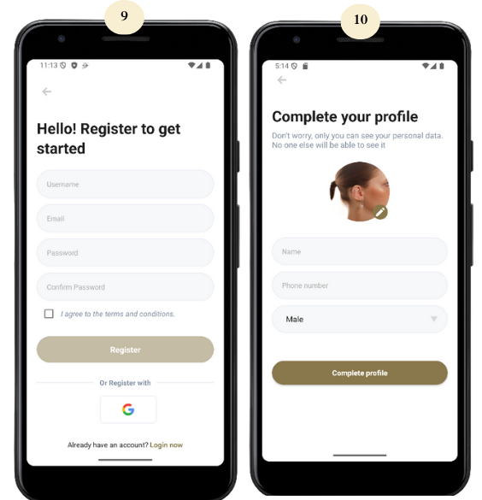

##### **Figure 15.** Register Account Process User Interface (Source: Authors)

If users choose to register, they are directed to screen 9 to enter their details. After submitting the form, their profile is successfully created and shown on screen 10.

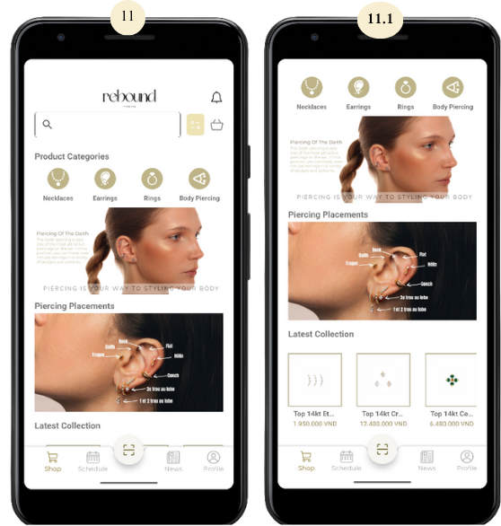

##### **Figure 16.** Main Page/Shopping Page User Interface (Source: Authors)

After login, users are directed to the Shopping Page (screens 11–11.1) featuring the logo, notification icon, search bar, categories, banners, and product collections in a top-down layout. A fixed navigation bar at the bottom provides access to Shop, Schedule, AR Camera, News, and Profile sections.

## 4.2. Product Browsing & Purchase User Interface

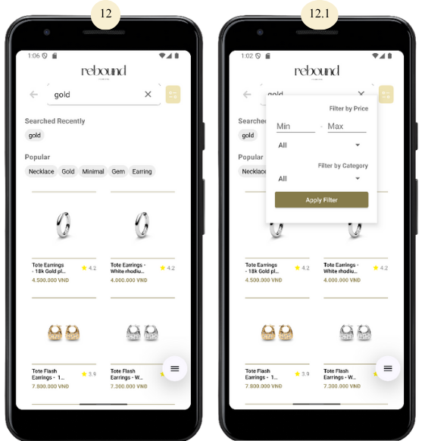

##### **Figure 17.** Search and Filter User Interface (Source: Authors)

With the search and sorting bar, users can not only look for the item they want by entering a keyword (Screen 12), but also filter the product list by price and category (Screen 12.1).

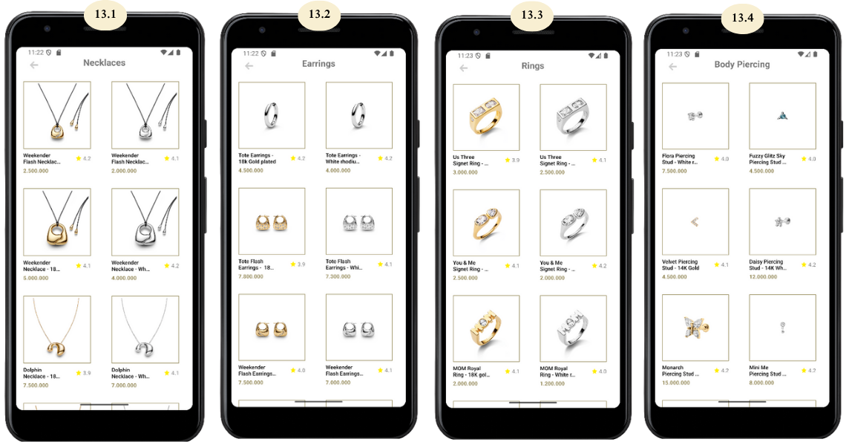

##### **Figure 18.** Product List Filtered by Categories User Interface (Source: Authors)

When a user selects a product category from the main shopping page (Screen 11), they are taken to the Product List screen, filtered by the selected category. Screens 13.1 to 13.4 display items under categories such as Necklaces, Earrings, Rings, and Body Piercing, respectively.

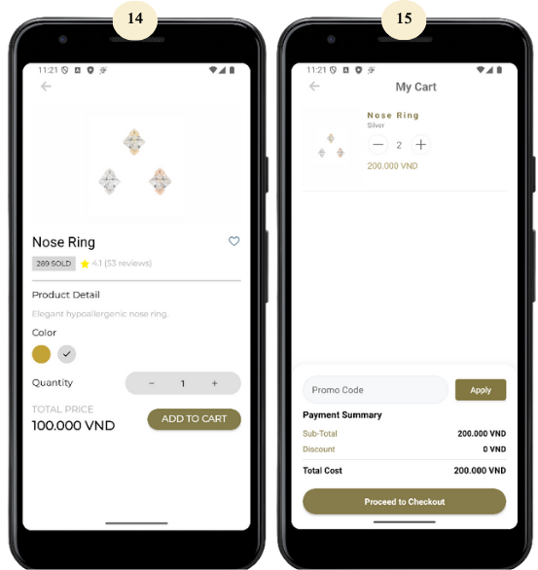

##### **Figure 19.** Product Details and Cart User Interface (Source: Authors)

After selecting a product, users are directed to the Product Details screen (14) to view information and choose options. Tapping “Add to Cart” leads to the Cart screen (15), where they can adjust items and proceed to checkout.

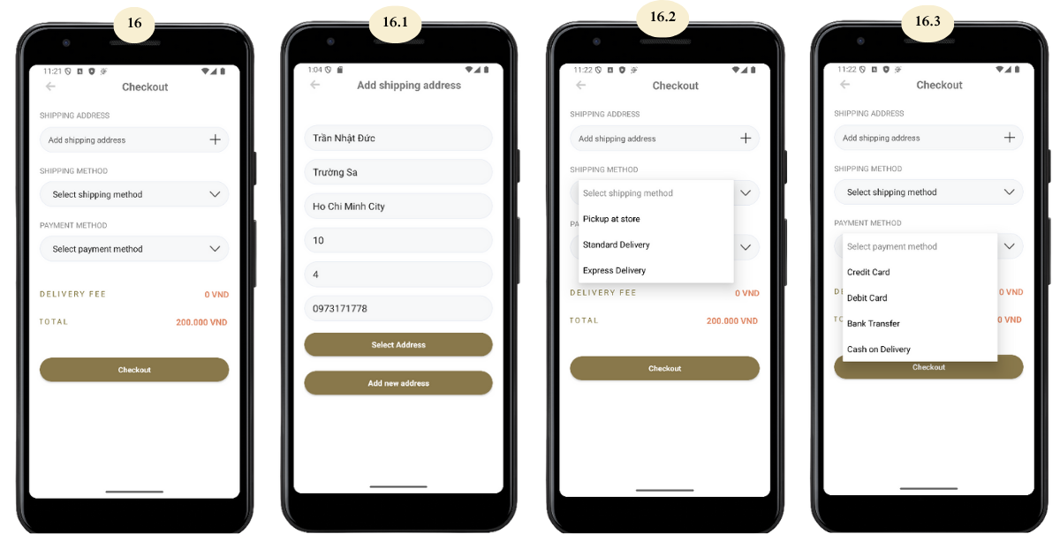

**Figure 20.** Checkout and Input Field Completion User Interface (Source: Authors)

In the Checkout screen (16), users provide a shipping address, select a delivery method (screen 16.2), and choose a payment option (screen 16.3). If no address is saved, they can add one via screen 16.1.

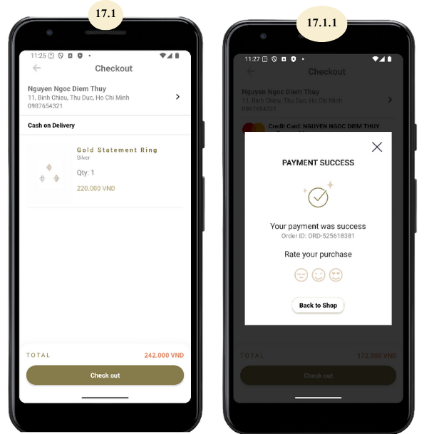

**Figure 21.** Checkout via “Cash on Delivery” Payment Method Process User Interface (Source: Authors)

When selecting Cash on Delivery, users confirm the order (screen 17.1) and are shown a success screen (17.1.1) indicating payment will be made upon delivery.



##### **Figure 22.** Checkout via “Credit Card” or “Debit Card” Payment Method Process User Interface (Source: Authors)

For Credit/Debit Card payments, users enter card details (screen 17.2) or select a saved card (17.2.1). After processing, a confirmation appears on screen 17.2.2.

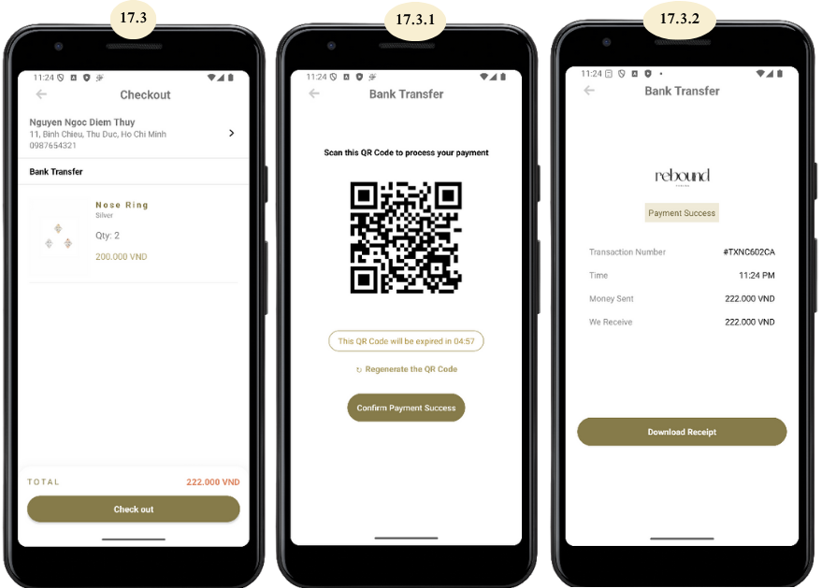

##### **Figure 23.** Checkout via “Bank Transfer” Payment Method Process User Interface (Source: Authors)

For Bank Transfer, users review their order (screen 17.3), scan a QR code or use bank details (17.3.1), then confirm the transfer via screen 17.3.2.

**4.3. Booking Service User Interface**

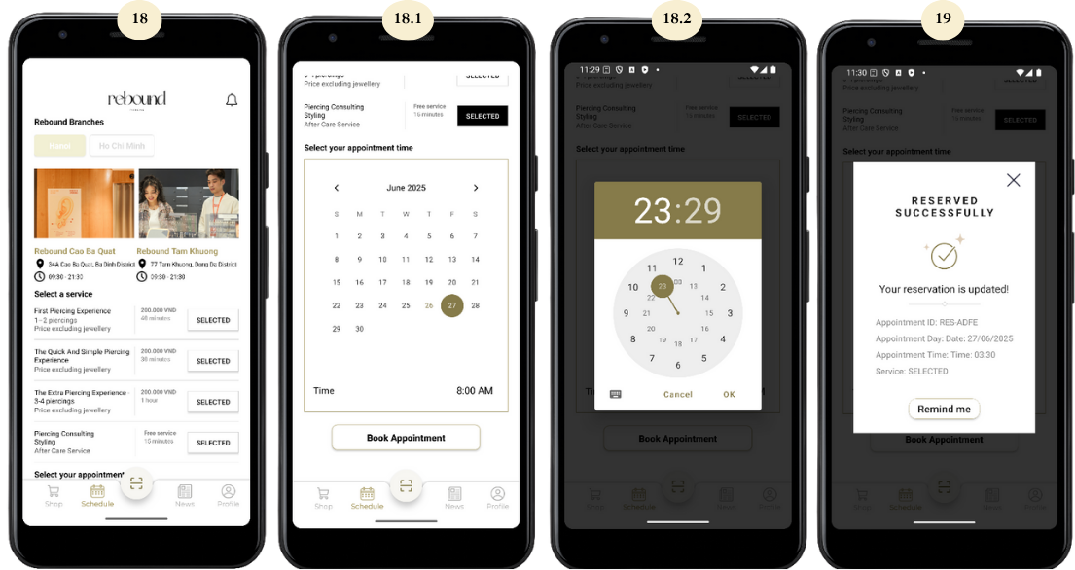

##### **Figure 24.** Booking Service Process User Interface (Source: Authors)

In the Schedule section, users can book a service by selecting a date (18.1) and time (18.2), then tapping “Book Appointment”. A confirmation and optional reminder appear on screen 19.

**4.4. AR Camera User Interface**

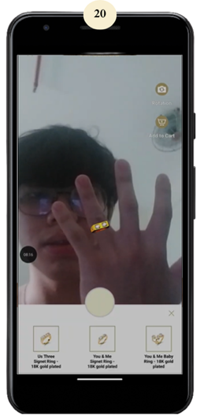

##### **Figure 25.** AR Camera Function User Interface (Source: Authors)

By tapping the AR Camera section, users are brought to a virtual try-on interface (screens 20 and 21), where they can preview how different piercing accessories would look on their face in real time using augmented reality.

# 5. DISCUSSION

The study demonstrates that integrating Augmented Reality (AR) and Machine Learning (ML) into a mobile shopping application significantly improves product visualization, decision-making, and user satisfaction. By enabling real-time virtual try-on of rings, the app enhances the online shopping experience while promoting sustainable consumption through reduced product returns and unnecessary purchases. The inclusion of features such as appointment booking, customer support, and account management supports a holistic shopping journey, reflecting strong alignment with user-centered design principles. Usability and accessibility are prioritized through lightweight implementation optimized for Android devices, catering to the growing mobile e-commerce market in Vietnam. Future upgrades, including expanded accessory support, iOS compatibility, brand integration, and AI-powered personalization, could further enhance the system’s value and contribute to broader sustainable fashion goals.

# 6. LIMITATIONS AND FUTURE WORKS

This study introduced a mobile application that integrates Augmented Reality (AR) and Machine Learning (ML) to improve the online shopping experience for fashion accessories, with a focus on rings. By enabling users to virtually try on products in real time, the app helps them make more informed purchasing decisions. This contributes to reducing unnecessary purchases and encourages more mindful, sustainable consumption behaviors. The inclusion of features such as appointment booking, user account management, and customer support enhances the overall shopping experience, making it more interactive and closer to in-store engagement. Furthermore, the app's lightweight design allows it to run efficiently on standard Android devices, improving accessibility in markets like Vietnam. Compared to previous research like Prajapat et al. (2022) and Egaji et al. (2019), this solution offers more comprehensive functionality and practical value. Fashion brands can adopt it without expensive hardware, making it a scalable and eco-friendly solution for a broad user base.

However, the current version still has some limitations. At this stage, the app is only available on Android devices, so users with iPhones cannot access it. It also supports virtual try-on for rings only, and does not yet include other popular accessories like earrings or necklaces. In addition, the system is designed specifically for the Rebound Piercing brand. To support other businesses, significant changes would be required. To improve the app in the future, several directions are possible. Expanding compatibility to iOS would increase its reach. Adding more accessory types, such as bracelets, glasses, or necklaces, would offer a fuller try-on experience. The system could also be redesigned to support multiple brands instead of just one. Finally, machine learning could be used to suggest products that match each user’s personal style, or even recommend eco-friendly options. These upgrades would make the app more helpful for users and contribute more strongly to sustainable fashion consumption.

# REFERENCES

Nguyen, Q., Truong, H., Nghiem, H., Nguyen, N., Dang, A., & Ha, L. (2025). The impacts of virtual try-on for online shopping on consumer purchase intention: The moderating role of technology experience. *Cogent Business & Management, 12*, Article 2500774.<https://doi.org/10.1080/23311975.2025.2500774>

Niinimäki, K., Peters, G., Dahlbo, H., Perry, P., Rissanen, T., & Gwilt, A. (2020). The environmental price of fast fashion. *Nature Reviews Earth & Environment, 1*(4), 189–200.<https://doi.org/10.1038/s43017-020-0039-9>

Zhou, J., Guo, Y., Zhang, L., & Xie, K. L. (2023). The role of augmented reality in enhancing customer decision-making in e-commerce. *International Journal of Information Management, 69*, 102678.<https://doi.org/10.1016/j.ijinfomgt.2023.102678>

Egaji, O. A., Asghar, I., Warren, W., Griffiths, M., & Evans, S. (2019, September). An augmented reality application for personalised diamond shopping. In *2019 25th International Conference on Automation and Computing (ICAC)* (pp. 1–6). IEEE.<https://doi.org/10.23919/IConAC.2019.8895044>

Ghosh, R., Chatterjee, R., & Kumar, V. (2021). AI in fashion: Personalized recommendations using deep learning. *International Journal of Information Management Data Insights, 1*(2), 100015.<https://doi.org/10.1016/j.ijimei.2021.100015>

Miao, Y., Huang, Z., Han, R., Wang, Z., Lin, C., & Shen, C. (2025). Shining yourself: High-fidelity ornaments virtual try-on with diffusion model. *arXiv preprint arXiv:2503.16065*.<https://doi.org/10.48550/arXiv.2503.16065>

Nguyễn, T. Q. N. (2024). Ứng dụng của thực tế ảo (VR) và thực tế ảo tăng cường (AR) trong thương mại điện tử [Applications of virtual reality (VR) and augmented reality (AR) in e-commerce]. *ResearchGate*.<https://www.researchgate.net/publication/378333496>

Nguyen, Q. H., Truong, T. H., Le, M. H., & Nguyen, D. L. N. (2025). The impacts of virtual try-on for online shopping on consumer purchase intention: The moderating role of technology experience. *Cogent Business & Management, 12*(1), Article 2500774.<https://doi.org/10.1080/23311975.2025.2500774>

Prajapat, R., Saini, R., & Yadav, V. (2022). AR-based virtual jewelry try-on using Android application. In *Proceedings of the 3rd International Conference on Innovative Computing and Communication (ICICC 2022)* (pp. 587–597). Springer.<https://doi.org/10.1007/978-981-19-1625-7_54>

La, T. A., Tran, D. T., Le, H. N., Ho, T. T., & Le, H. S. (2024). A hybrid model between ARIMA and LSTM for sales volume forecasting on time series. In S. K. Duyen (Ed.), *Proceedings of the International Conference UEL-SEB 2024: Innovation & sustainability: Impact on economy & business* (pp. 705–732). Vietnam National University Ho Chi Minh City Press.

Nguyen, N., Lam, H. T., Tran, T. A., Nguyen, V. H., & Tran, D. T. (2024). Machine learning-based model for credit fraud detection in imbalanced dataset using class weight tuning and ensemble technique. In S. K. Duyen (Ed.), *Proceedings of the International Conference UEL-SEB 2024: Innovation & sustainability: Impact on economy & business* (pp. 928–950). Vietnam National University Ho Chi Minh City Press.

Azuma, R. T. (1997). A survey of augmented reality. *Presence: Teleoperators & Virtual Environments, 6*(4), 355–385.

Milgram, P., & Kishino, F. (1994). A taxonomy of mixed reality visual displays. *IEICE Transactions on Information and Systems, E77-D*(12), 1321–1329.

Yang, J., & Lin, Z. (2024). From screen to reality: How AR drives consumer engagement and purchase intention. *Journal of Digital Economy, 3*, 37–46.<https://doi.org/10.1016/j.jdec.2024.07.001>

Nguyen, Q. H., Hanh, T. T., Hanh, N. L. M., Nhi, N. D. L., Anh, D. N., & Linh, H. T. (2025b). The impacts of virtual try-on for online shopping on consumer purchase intention: The moderating role of technology experience. *Cogent Business & Management, 12*(1).<https://doi.org/10.1080/23311975.2025.2500774>

Mitchell, T. M. (1997). *Machine learning*. McGraw-Hill.

Kim, J., Kim, M., Park, M., & Yoo, J. (2022). Immersive interactive technologies and virtual shopping experiences: Differences in consumer perceptions between augmented reality (AR) and virtual reality (VR). *Telematics and Informatics, 77*, 101936.<https://doi.org/10.1016/j.tele.2022.101936>

Olson, E. D., Arendt, S. W., FitzPatrick, E., Hauser, S., Rainville, A. J., Rice, B., & Lewis, K. L. (2019). Marketing mechanisms used for summer food service programs. *Journal of Nonprofit & Public Sector Marketing, 32*(5), 465–487.<https://doi.org/10.1080/10495142.2019.1589632>

Orús, C., Ibáñez-Sánchez, S., & Flavián, C. (2021). Enhancing the customer experience with virtual and augmented reality: The impact of content and device type. *International Journal of Hospitality Management, 98*, 103019.<https://doi.org/10.1016/j.ijhm.2021.103019>

Somlith, A. (2024, March 27). Boost your spring revenue: Capture sales this spring shopping season and engage shoppers with AR & VR features. *PPC Ad Editor*.<https://www.ppcadeditor.com/boost-your-spring-revenue-capture-sales-this-spring-shopping-season-and-engage-shoppers-with-ar-vr-features/>

Ngo, T. T. A., Tran, T. T., An, G. K., & Nguyen, P. T. (2025). Investigating the influence of augmented reality marketing application on consumer purchase intentions: A study in the e-commerce sector. *Computers in Human Behavior Reports*, 100648.<https://doi.org/10.1016/j.chbr.2025.100648>

Nguyen, H. N. (2022). Motivations and barriers to embracing augmented reality: An exploratory study with Vietnamese retailers. *Innovative Marketing, 18*(3), 28–37.<https://doi.org/10.21511/im.18(3).2022.03>

Nguyen, T. V., Nguyen, T. V., & Nguyen, D. V. (2024). Perceived quality of virtual reality and augmented reality technology influences travel intention: The case of Vietnam. *Journal of Hunan University (Natural Sciences), 51*(5), 1–15.<https://doi.org/10.55463/issn.1674-2974.51.5.2>

Preeti, P. J., Nandhini, G., Sreeya, B. P., & Chandu, B. E. (2022). A novel jewellery recommendation system using machine learning and natural language processing. *International Research Journal of Engineering and Technology (IRJET), 9*(6), 3501–3513.<https://www.irjet.net/archives/V9/i6/IRJET-V9I6691.pdf>

Hilken, T., De Ruyter, K., Chylinski, M., Mahr, D., & Keeling, D. I. (2017). Augmenting the eye of the beholder: Exploring the strategic potential of augmented reality to enhance online service experiences. *Journal of the Academy of Marketing Science, 45*(6), 884–905.<https://doi.org/10.1007/s11747-017-0541-x>

Kim, J., & Forsythe, S. (2008). Adoption of virtual try-on technology for online apparel shopping. *Journal of Interactive Marketing, 22*(2), 45–59.<https://doi.org/10.1002/dir.20113>

Raffo, A., Fugacci, U., Biasotti, S., Rocchia, W., Liu, Y., Otu, E., Zwiggelaar, R., Hunter, D., Zacharaki, E. I., Psatha, E., Laskos, D., Arvanitis, G., Moustakas, K., Aderinwale, T., Christoffer, C., Shin, W., Kihara, D., Giachetti, A., Nguyen, H., ... Tran, M. (2021). SHREC 2021: Retrieval and classification of protein surfaces equipped with physical and chemical properties. *Computers & Graphics, 99*, 1–21.<https://doi.org/10.1016/j.cag.2021.06.010>

Yang, S., Carlson, J. R., & Chen, S. (2019). How augmented reality affects advertising effectiveness: The mediating effects of curiosity and attention toward the ad. *Journal of Retailing and Consumer Services, 54*, 102020.<https://doi.org/10.1016/j.jretconser.2019.102020>

Prajapat, J., Sathe, M., Shah, S., & Raut, C. (2022). Jewellery try-on using AR. *International Journal of Computer Engineering in Research Trends, 9*(4), 116–120.<http://www.ijcert.org>

|  |
| --- |
|  |
| **Acknowledgements** **and Financial Disclosure** |
|  |
| **Acknowledgement**  This research was funded by the University of Economics and Law, Vietnam National University Ho Chi Minh City, Vietnam. The authors would like to express their sincere gratitude to Ph.d Tran Duy Thanh for his valuable guidance and support throughout the research process, as well as to the University for providing the resources that made this study possible.  **Availability of Materials**  The source code and submission materials for the mobile application are openly accessible:  H. S. Tin. *REBOUND Group 5 – Submissions*. Available at:<https://github.com/hoaloken61998/REBOUNDGroup5_Submissions>. |
|  |